|  |  |
| --- | --- |
| Renmar M. Lescano | CMSC 127 – 1 LAB |
| Prof. Christi Florence C. Cala-or | 23 May 2022 |

**Laboratory Activity 4**

**In *deleteEmployee.php***

Here, deleting the data of John Doe was successful and it redirected me to *index.php*.

I modified the lines where the *deleteEmployee.php* call is located in the *listOfEmployees_Lab4.php* file.

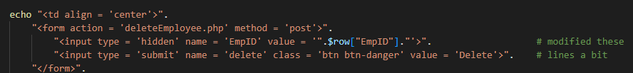

Then, in the *deleteEmployee.php* file, the $_POST was used with the argument “delete” that was also based from the <input> syntax above.

